**Conservation of Biodiversity, biosafety and access to genetic resources and benefit sharing arising from their utilization**

**Streamlining Biosafety and ABS into national biodiversity strategies**

In response to the Assembly decision to include biodiversity within the priorities of the AU the Commission has been engaged in supporting Member States in the coordinated implementation of their obligations under the Convention on Biological Diversity (CBD) and its Protocols (the Cartagena Protocol on Biosafety and the Nagoya Protocol on Access to genetic resources and Benefit Sharing arising from their utilization (ABS). AU Member States as Parties to the CBD are required to integrate the implementation of the CBD and its Protocols to improve efficiency and effectiveness. In this regard the Conference of the Parties (COP) requested Parties to integrate biosafety and ABS in to the national biodiversity strategies and action plans and other relevant sectoral policies. The Department hence co-organized a workshop with the Secretariat of the CBD from 9-12 February 2016 in Addis Ababa where mainstreaming and coordination at the national and regional levels were discussed and agreed. The workshop shed light on the status of implementation of the Cartagena Protocol on Biosafety in the African region and identified existing national and regional tools, strategies and opportunities for improving the integration of biosafety into national biodiversity strategies and action plans vis-à-vis the national development plans. At the level of the AU, the African Union Policy on Biosafety that includes the African Strategy and the Model Law was reflected upon as a key instrument in the mainstreaming process.

**Continental Coordination**

Albeit the recognition on the importance of biodiversity, there has not been much coordination at the level of the continent in the manner of support in implementing the CBD and its Protocols. Therefore the Department constituted a Continental Coordination Committee on biodiversity comprised of the key pan-African actors. The Committee is composed of stakeholder departments within the Commission such as HRST, the Department of Rural Economy and Agriculture (DREA), Department of Trade and Industry (DTI), Department of Social Affairs (DSA) and the Office of the Legal Counsel (OLC) as well as concerned AU regional offices such as the AU Inter-African Bureau of Animal Genetic Resources (AU-IBAR), AU Scientific Technological and Research Commission (AU-STRC), AU institute of agricultural research for development in semi-arid Africa (AU-SAFGRAD), the regional economic communities, the NEPAD Planning and Coordination Agency, Pan African Initiatives such as the ABS Capacity Development Initiative, the UN Agencies and the African Development Bank. The first meeting of the Continental Committee was held from June 29th to 30th 2016 at the AUC headquarters which exchanged on the state of play regarding on going initiatives in support of Member States in the field of biodiversity, biosafety and ABS. The Committee also agreed on its terms of reference and joint activities forward including coordinating support in the preparations of the African Group of negotiators for the COP 13 in December. The Committee will meet every year to update progress on implementation at the level of each constituency and coordinate implementation of decisions by AU Policy organs.

**Preparations for COP 13, COP-MOP 8 and COP-MOP 2**

The Department has further advanced its coordinator role on behalf of the Commission in co-organizing an African regional preparatory meeting with the Secretariat of the CBD and the CITES[1] from 8th to 12th August 2016 at the UNECA Head Quarters in Addis Ababa where the Department was in charge of the closed session discussions of the African Group of Negotiators that lead towards common African positions on the upcoming agenda items of the COP 13, MOP 8[2] and MOP 2[3] respectively.

A final African Coordination Meeting will be organized right before the opening of COP 13, COP-MOP 8 and COP-MOP 2 of the CBD and its Protocols on December 1st 2016 which is expected to be key in the preparations of the African Group and in providing an avenue for formulating the African Common Positions also helping the group in strategizing the African negotiating approach. The Commission will be represented at the COP and MOPs as an observer lending support to the African Group on technical issues as well as sharing developments with the global body on implementation of the CBD and its Protocols at the level of the AU.

Caption # 1:

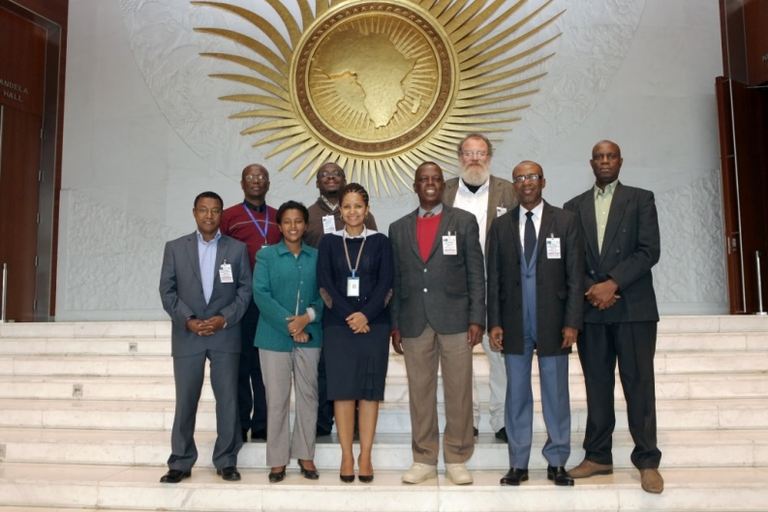Caption #2: First meeting of the Continental Coordination Committee on matters of Biodiversity

1. Convention on International Trade on Endangered Species
2. Conference of the Parties serving as the Meeting of the Parties of the Cartagena Protocol on Biosafety
3. Conference of the Parties serving as the Meeting of the Parties of the Nagoya Protocol on ABS